**The role of air pressure transients on the spread of bacteria from water trap seals in clinical settings: A laboratory based pilot study**

Prof. M. Gormley, Dr. D. Kelly Dr. T. Aspray (Solidsense) Dr. D. Campbell, Mr. T. Dight

# Introduction

## Summary

Hand-wash sink traps are increasingly being reported as the source of hospital-acquired infections worldwide [1-5]. There is an urgent need for mechanisms to mitigate the risks posed by opportunistic pathogens that thrive in sink traps. In clinical areas especially, these hand-wash sink traps are known to be the source of outbreaks of difficult to treat infections caused by multidrug resistant (MDR) pathogens, i.e. bacteria carrying antimicrobial resistance (AMR) of critical clinical relevance such as carbapenem-resistance.

One cause of pathogen ingress from hand-wash sink traps is air pressure transients generated during normal operation of the wastewater system [6-8]. These ‘transients’ travel at the speed of sound and can cause the ingress of both aerosols and large droplets from the sink trap into the sink itself, potentially contaminating the sink and tap surface. This transient phenomenon is related to factors such as the building height and complexity, with either factor increasing the risk of large air pressure transients occurring. Clinical buildings and hospitals tend to be complex by design.

Our hypothesis for this project was that by better managing air pressure transients in the wastewater systems of clinical and hospital buildings, the spread of MDR pathogens from hand-wash sink traps can be reduced, therefore, reducing numbers of nosocomial infections.

This hypothesis was tested by carrying out a pilot study investigation at Heriot-Watt University’s laboratory facility. This work examined the mechanisms and extent of aerosol generation and ingress as a result of air pressure transients and considered an alternative solution by installing innovative Active Ventilation Measures (AVM) on the wastewater system.

## Impact of air pressure transients on sink traps

From a system design perspective, the hand-wash sink trap provides the main defence against the ingress of contaminated foul air from the building’s wastewater system. The “water trap seal” is located at every system appliance, usually at the extremities of pipe branches which connect to the main vertical soil stack and sewer. The water trap seal is, therefore, an interface between the interior building and the wastewater system and sewer.

It has been long recognised that protecting the water trap seal is the primary aim of the wastewater system design. A consequence of the random wastewater discharge from system appliances is the generation of air pressure transients inside the wastewater system.

A negative air pressure transient will suck water out of the water trap seal, whistle a positive air pressure transient will blow water back into the appliance. The result from both types of transient can be a breached water trap seal, at which point the wastewater system and sewer will vent into the interior of the building. These air pressure transients are managed by the wastewater system ventilation system, which traditionally involved an additional network of pipes to provide additional air where needed [9,10]. While this can be relatively successful for negative suction pressures, they do not deal with positive air pressure transients. The presence of these air pressure transients also cause air turbulence within the system and, when coupled with water flows from system discharges, act as a ‘mixer’, thus partially explaining the mode of transfer of microbes (potentially including MDR pathogens) between the wastewater system and hand-wash sink traps.

## Existing evidence of aerosol ingress from hand-wash sink traps

Often located in patient care areas, sink traps act as reservoirs for long-term transmission of multidrug resistant pathogens [11]. Many reports have shown genetic association between pathogens found in sink traps and those found in patients [12,13], with sinks in intensive care units (ICUs) even being associated with increased rates of hospital-acquired infection [14,15].

Initial data gathered on this phenomenon is shown in Figure 1 where the consequence of a positive air pressure transient (< 2 seconds in duration) on aerosol generation is shown. In this preliminary example, aerosol generation was measured above the plug strainer of a non-clinical sink (A). The air pressure transient creates a “spike” in the number of aerosols generated (B). The cumulative number of aerosols after 2 minutes was found to be 2.5 x 102 (C). As the water trap seal was partially intact after the event, it would be unlikely to know that such an event had taken place.

This initial data shows the potential for air pressure transients to lead to the ingress of aerosols from hand-wash sink traps into the interior of the building. However, it did not provide evidence of pathogens contained within the aerosols. This current pilot study aimed to provide this evidence.

(A) (B) (C)

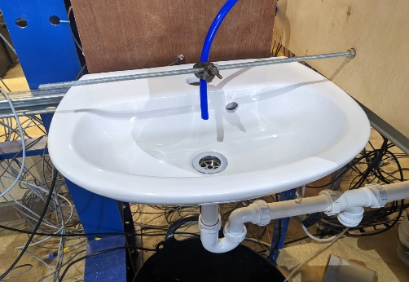

**Figure 1. Ingress of aerosols from the water trap seal due to the arrival of a positive air pressure transient. (A) shows the location of the aerosol probe; (B) shows the spike in aerosols at 30 seconds due to the pressure wave; and (C) shows the cumulative aerosol measured over the 120 second period. The graph is adjusted to take account of background aerosols in the room.**

## The Intervention

Recent innovations to manage turbulent airflows have seen the introduction of components with moving parts to alleviate pressure fluctuations in wastewater systems, such as Air Admittance Valves (AAVs), Positive Air Pressure Attenuators (PAPAs), and waterless traps. These types of pressure alleviation devices are termed ‘active ventilation’ [10]. The classical systems where air pressure fluctuations are alleviated by a collection of ventilation pipes only, are referred to as ‘passive ventilation’ systems.

Note: Since this small pilot study is concerned more with the alleviation of positive pressures and their effects on causing the ingress of micro-organisms into sinks, the effects of negative pressure waves and their alleviation with AAVs was not tested.

To mitigate the effects of destructive air pressure transients, an **ACTIVE VENTILATION** approach is being proposed in this project, see Figure 2, in order to calm the pressure regime within the system and stop blowback of harmful aerosolised microbes from the water trap seal into the sink. These active ventilation approaches have been shown to be effective against large air pressure transients as identified after the SARS coronavirus outbreak at Amoy Gardens in 2002, which was confirmed by other investigators [17].

Positive air pressure transient alleviation using the PAPA has been shown to be effective [6,7] but these methods are still not in widespread use. Attenuation of positive air pressure transients by the PAPA, in excess of 90%, have been reported. Recent modelling analysis has highlighted how these active ventilation approaches can be incorporated into codes and standards globally and improve pressure related problems associated with tall and complex buildings in particular [18].

**Figure 2: Installation of a PAPA on the test rig at the Heriot-Watt University laboratory. The device is arranged optimally to protect the sink trap nearby.**

# Methodology

The methodology of this Pilot Study was designed to provide evidence of bioaerosol ingress from hand-wash sink traps as a result of air pressure transients within the wastewater system. Furthermore, this study sought microbial evidence of pathogens being carried within these aerosols and deposited on the hand-wash sink surface. The methodology below is divided into three parts: (i) description of the test rig and air pressure transient generator; (ii) aerosol detection and counting; and (iii) microbial evaluation of aerosol pathogen transmission.

## Test rig and air pressure transient generator

The test-rig was designed with a standard NHS hand-wash sink and trap connected to a pressure transient generator (PGT) via a 50 m length of 100 mm diameter wastewater drainage pipe, see Figure 3. This length of pipe allowed a clear and repeatable air pressure transient to be generated and recorded. The hand-wash sink was an Armitage Shanks S2254(01) Portman 21 50 washbasin fitted with an S8720(AA) strainer & tail (compliant with SHTM64 LB G L/M and SHTM64 WT3, respectively). The sink trap was an Armitage Shanks S8920(67) (compliant with SHTM64 TRR1) and the tap was an A6697 (AA) TP6 Contour 21+ tap (compliant with SHTM 64 TP6).

In some experiments, a PAPA was added to the test-rig at a connection adjacent to the hand-wash sink, as indicated in Figure 3.

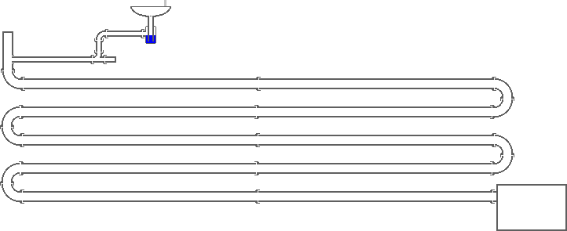

Connection point for PAPA

PTG

Hand-wash sink & trap

**Figure 3: Schematic of test-rig showing the hand-wash sink & trap, pressure transient generator (PTG), and PAPA connection point**

The PTG creates a controlled air pressure transient that traverses the test-rig towards the hand-wash sink and trap. The amplitude of the air pressure transient can be increased or decreased manually using a dial.

## Aerosol detection and counting

To detect and count the aerosols at the hand-wash sink, a TSI Aerodynamic Particle Sampler 3321 (APS) was used. An antistatic tube was connected to the APS at one end and, at the other end, positioned above the sink strainer, in-line with the tap outlet, see Figure 4.

Sample air entering the APS via the antistatic tubing is split into two streams: (i) the sampling air, which contains the particles which are observed in the APS sensor, and (ii) the working air. At entry to the machine, the air is split into these two streams with nominal volumetric flow rates of 1 l⁄min being sampled, and 4 l⁄min being filtered and used as the working air. Air enters the APS sensor in two concentric inlets; the sampling air enters through the central inlet, exiting via a nozzle which accelerates the air, and the working air enters the sensor through an annular inlet which isolated the sampling fluid from the ambient air in the sensor, minimising the risk of particle recirculation. Two parallel beams of laser light pass through the core of the APS sensor, normal to the direction of travel. As aerosols passes through each of the beams, a photodetector counts the number of aerosols as well as the particle size distribution.

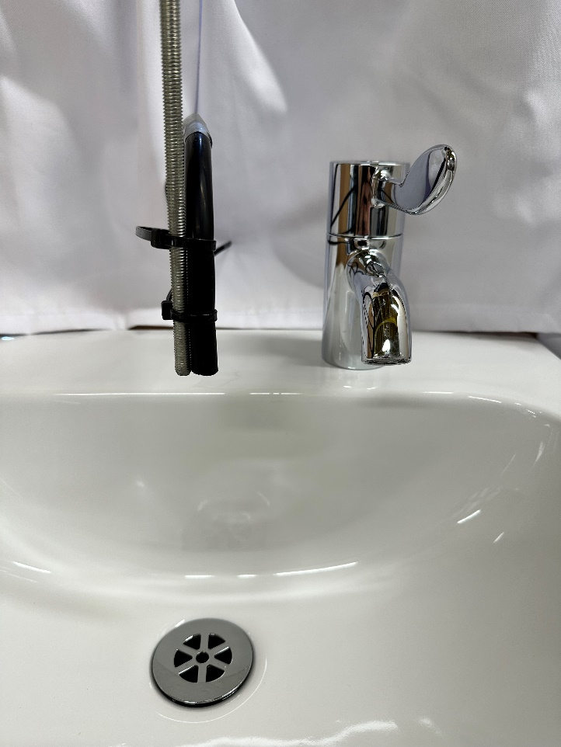

**Figure 4: APS antistatic tubing positioned above the sink strainer and in-line with the tap outlet**

## Microbial evaluation of aerosol pathogen transmission

The water within the hand-wash sink trap was replaced with a culture of *Pseudomonas alloputida* KT2440 to represent a sink trap contaminated with, for example, MDR pathogens. The culture preparation and quantification, and experimental microbial analysis procedures are described below.

### Culture preparation and quantification

A pure culture of *Pseudomonas alloputida* KT2440 was inoculated into Erlenmeyer flasks containing tryptone soya broth (TSB) and incubated overnight at 30 °C with orbital shaking. An aliquot (1 ml) of the overnight culture was used to determine cell concentration by serial dilution and triplicate spread plating. Serial dilution spread plates were incubated at 30 °C and colonies counted at 48 h. The concentration of the culture was calculated as 2.1 x 1011 cfu ml-1 based on the average of the triplicate plates.

### Experiment microbial analysis

Sink and tap surfaces were sterilized prior to each experiment with domestic surface cleaner and wiping with fresh paper towel to dry. After each experiment, sink surface locations were sampled using tryptone soya agar (TSA) contact plates (Oxoid Ltd, Basingstoke, UK). The exception to this was in assessing for tap contamination where TSA contact plates were stuck to the tap with blue tack (Bostik) before the experiment. TSA contact plates stuck to the tap pointed in a downwards direction towards the sink which also helped to avoid gravimetric deposition of environmental contaminants when exposed.

After each experiment, the TSA contact plates and lids were sealed with Parafilm® sealing film (Bemis, Wisconsin, USA) for transportation to the laboratory. TSA contact plates were incubated at 30 °C for 48 h. After 48 h colonies were counted (where possible) and plates photographed. Plates were incubated for a further five days, recounted and photographed. Colonies were also assessed for environmental contaminants.

### Environmental contaminants

At seven days incubation the presence of environmental contaminants was determined based on colony colour / morphology. One obvious environmental contaminant (with distinctive colour) was not further considered. A second presumptive environmental contaminant, similar in colour to the inoculum, was streaked onto fresh agar alongside *P. alloputida* KT2440 culture to provide further assurance of it being an environmental contaminant.

# Results

## Generated air pressure transients

The range of peak air pressure transients recorded adjacent to the hand-wash sink trap are summarised in Figure 5. The PTG allows a range of transient amplitudes to be generated by opening and closing the vent holes on the fan enclosure. It can be seen that having more vent holes open, reduces the peak air pressure transient. Overall, the peak air pressure transients recorded range from 142-209 mm water gauge.

**Figure 5: Peak air pressure transients generated by the PTG**

## Aerosol detection and count

For each generated air pressure transient, the resultant number of aerosols at the sink were detected and counted by the APS. Figure 6 and 7 represent a “typical” and “large” aerosol count, respectively. Figures 6a and 7a show the raw particle count. Figures 6b and 7b show the particle count, less the mean particle count (excluding the peak), to remove the background particle level. Finally, Figures 6c and 7c show the cumulative particle count, with a pre-peak baseline count subtracted at each time step to remove the background particle level.

(a)

(b)

(c)

**Figure 6: A “typical” aerosol count at the hand-wash sink as recorded by the APS: (a) the raw particle count; (b) the particle count, less the mean particle count (excluding the peak); (c) the cumulative particle count, with a pre-peak baseline count subtracted at each time step to remove the background particle level**

(a)

(b)

(c)

**Figure 7: A “large” aerosol count at the hand-wash sink as recorded by the APS: (a) the raw particle count; (b) the particle count, less the mean particle count excluding the peak; (c) the cumulative particle count, with a pre-peak baseline count subtracted at each time step to remove the background particle level.**

From the data presented in Figures 6 and 7, a clear aerosol “spike” in the hand-wash sink can be seen to occur as a result of the air pressure transient at the sink trap. Looking at the data in Figures 6b and 7b, respectively, it can be seen that a peak of 64 aerosols are generated from the “typical” count, and a peak of 128 aerosols are generated from the “large” count. In both cases, the cumulative aerosol counts reach around 200 aerosols over the event.

The correlation between peak air pressure transient and aerosol count is shown in Figure 8.

**Figure 8: Variation of aerosol count with peak air pressure transient**

The relationship between the location of the APS intake and the aerosol count was also assessed. The APS intake was located directly above the strainer, and for most experiments, it was held at the height of the tap outlet. For the assessment, it was moved closer to the strainer in one-third increments. Figure 9 shows that as the APS intake was moved closer to the strainer, there is a general increase in measured aerosol count.

**Figure 9: Variation of Particle Count with APS Sampler Height**

The final assessment, presented in Figure 10, demonstrates the use of PAPAs as a way of mitigating the air pressure transients from affecting the sink trap.

The air pressure and the peak number of aerosols detected reduces with the installation of the PAPA. Note: it is also likely that aerosols and droplets much greater than 20 µm (the limit of the APS) were also reduced.

## Reduction in air pressure at the sink due to installation of PAPA

Pressure transients were generated in the PTG and static pressure was measured in the pipe behind the sink. Therefore, the pressure transducer was reading the pressure being experienced by the water trap seal. Figure 10 shows the effect on the pressure of including PAPAs in the system – the surge wave is destroyed and the resulting pressure wave had a very limited impact on the water trap seal and the aerosols produced. For comparison, Figure 11 shows the pressure at the base of the stack measured in a real building. This confirms that the range of pressures used in the experiments was valid.



**Figure 10: Pressure at the rear of sink trap with and without PAPA installed. Note that without any protection from positive pressure, an oscillation is set up in the water trap which also instigates a negative pressure wave. Water was observed coming through the sink strainer when no PAPA was installed**

**Figure 11. Pressure trace measured at the base of a stack under peak flow conditions.**

## Microbial detection at hand-wash sink

TSA contact plates were used to take samples of the sink surface following generation of the air pressure transients. Figure 12 shows that sample locations and labelling convention. Figure 13 shows the TSA contact plates taking samples at locations E and C.

**A**

**B**

**C**

**D**

**E**

Strainer

Far left side, aligned with strainer

Vertical back panel, aligned with strainer

Culture plate at tap (pointed towards strainer)

Near right side, aligned with strainer

Tap

**B**

**C**

**D**

**E**

**A**

Strainer

**Figure 12: Plan view of hand-wash sink indicating TSA contact plate sample locations**

**Figure 13: TSA contact plate samples being taken at locations E and C**

The microbial results of the TSA contact plate samples are summarised in Table 1. The peak air pressure transients of each test are indicated, together with the resultant plate counts. In each test, the handwash sink trap was re-filled with the *Pseudomonas alloputida* KT2440 stock culture, the only exceptions being tests, 1, 2, and 10 which used water only as checks. Whilst test 1A shows a positive plate count of 2 colonies, these have been proven to be environmental contaminants and can be discounted.

From the eight tests conducted with *Pseudomonas alloputida* KT2440 stock culture in the sink trap, six resulted in positive contamination of the sink and/or tap. The area at and around the sink strainer is commonly contaminated (3A, 4A, 5A, 6A, 8E, and 11CR). In two cases (6A and 8E) the TSA contact plates were found to be entirely covered in bacteria (referred to as “lawn”). Furthermore, the tap outlet was found to be contaminated (11D). Figure 14 shows example TSA contact plates with colony counts.

**Table 1: Plate counts of Pseudomonas alloputida KT2440 colonies for the series of tests in response to generated air pressure transients at the sink trap**

|  |  |  |
| --- | --- | --- |
| **Sample ID** | **Peak Air Pressure Transient**  **(mm water gauge)** | **Plate count** |
| 1A | n/a | 2 |
| 2 | n/a | n/a |
| 3A | 60 | 1 |
| 3B | 0 |
| 4A | 80 | 2 |
| 4C | 0 |
| 5A | 120 | 9 |
| 6A | 140 | Lawn |
| 6C | 0 |
| 7D | 160 | 0 |
| 8C | 180 | 0 |
| 8D | 0 |
| 8E | Lawn |
| 9D | 180 | 0 |
| 10 | n/a | n/a |
| 11CR | 190 | Positive |
| 11D | ~5 |

**Figure 14: Examples of TSA contact plates showing *Pseudomonas alloputida* KT2440 colony counts**

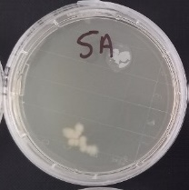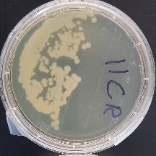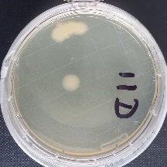

# Conclusion

The results of this Pilot Study provide evidence that the hand-wash sink and tap can become contaminated as a result of air pressure transients within the wastewater system disturbing the sink trap and causing aerosols and droplets to enter the sink.

Specifically, the study has confirmed that:

1. Positive pressure waves cause ingress of contaminated water into a sink during an event
2. When the sink trap is contaminated with bacteria, this can be detected on the surface of sink, at the strainer, and on the tap – CFUs were reported at all these locations.
3. The strainer was contaminated even when there was no visible ingress of water to the sink (contamination under the strainer)
4. Positive pressures occur naturally in plumbing systems and can be exacerbated by other activities such as jetting of horizontal lines for blockage clearance.
5. Positive pressure waves generate aerosols which were located at various locations above the sink strainer.
6. Aerosols were detected even when no visible sign of ingress occurred (agitation below the strainer level)
7. Pressure alleviation in the wastewater system reduces the pressure experienced by the sink trap, reduces the generation of aerosols, and reduces the ingress of contaminated water into the sink.

This study has provided microbial evidence of contamination of the sink and tap, as well as providing data of the aerosol count generated at the hand-wash sink from the effects of air pressure transients within the wastewater system.

More work is recommended on the alleviation of positive pressure and the influence of water trap seal design on the contamination of the sink and the interior of the building from pathogens in the building wastewater system. Future studies would also benefit from more extensive examinations of the topic and include a wider range of aerosol and droplet size.

# References

1. Lowe C, Willey B, O’Shaughnessy A, Lee W, Lum M, Pike K, Larocque C, Dedier H, Dales L, Moore C, McGeer A. 2012. Outbreak of extended spectrum beta-lactamase-producing Klebsiella oxytoca infections associated with contaminated handwashing sinks. Emerg Infect Dis 18: 1242–1247.
2. Starlander G, Melhus A. 2012. Minor outbreak of extended-spectrum beta-lactamase-producing Klebsiella pneumoniae in an intensive care unit due to a contaminated sink. J Hosp Infect 82:122–124.
3. Kotsanas D, Wijesooriya W, Korman T, Gillespie E, Wright L, Snook K, Williams N, Bell J, Li H, Stuart R. 2013. “Down the drain”: carbapenemresistant bacteria in intensive care unit patients and handwashing sinks. Med J Aust 198:267–269.
4. Roux D, Aubier B, Cochard H, Quentin R, van der Mee-Marquet N. 2013. Contaminated sinks in intensive care units: an underestimated source of extended-spectrum beta-lactamase-producing Enterobacteriaceae in the patient environment. J Hosp Infect 85:106 –111.
5. Leitner E, Zarfel G, Luxner J, Herzog K, Pekard-Amenitsch S, Hoenigl M, Valentin T, Feierl G, Grisold AJ, Hogenauer C, Sill H, Krause R, ZollnerSchwetz I. 2015. Contaminated handwashing sinks as the source of a clonal outbreak of KPC-2-producing Klebsiella oxytoca on a hematology ward. Antimicrob Agents Chemother 59:714 –716.
6. Swaffield, J.A.; Campbell, D.P.; Gormley, M. 2005a Pressure transient control: Part I - Criteria for transient analysis and control. *Build. Serv. Eng. Res. Technol.* **2005**, *26*.
7. Swaffield, J.A.; Campbell, D.P.; Gormley, M. 2005b Pressure transient control: Part II - Simulation and design of a positive surge protection device for building drainage networks. *Build. Serv. Eng. Res. Technol.* **2005**, *26*,
8. Gormley, M., Aspray, T. J. and Kelly, D. A. (2020) ‘COVID-19: mitigating transmission via wastewater plumbing systems’, The Lancet Global Health, 8(5), p. e643. doi: 10.1016/S2214-109X(20)30112-1.
9. Gormley, M. and Kelly, D.A. Pressure transient suppression in drainage systems of tall buildings. *Build. Res.* *Inf.* **2018**, doi:10.1080/09613218.2017.1412097.
10. Swaffield, J.A. (2010) Transient Airflows in Building Drainage Systems, Spon, London.
11. Hamerlinck H, Aerssens A, Boelens J, Dehaene A, McMahon M, Messiaen A-S, Vandendriessche S, Velghe A, Leroux-Roels I, and Verhasselt B. 2023. Sanitary installations and wastewater plumbing as reservoir for the longterm circulation and transmission of carbapenemase producing Citrobacter freundii clones in a hospital setting. Antimicrobial Resistance & Infection Control. 12:58. 1-13.
12. Decker B, Palmore T. 2013. The role of water in healthcare-associated infections. Curr Opin Infect Dis 26:345–351.
13. Centers for Disease Control and Prevention. 2013. Antibiotic resistance threats in the United States. Centers for Disease Control and Prevention, Office of Infectious Disease, Atlanta, GA.
14. Fucini G-B, Geffers C, Schwab F, Behnke M, Sunder W, Moellmann J, Gastmeier P. (2023). Sinks in patient rooms in ICUs are associated with higher rates of hospital-acquired infection: a retrospective analysis of 552 ICUs. The Journal of Hospital Infection. 139, 99-105.
15. Diorio-Toth L, Wallace MA, Farnsworth CW, Wang B, Gul D, Kwon JH, Andleeb S, Burnham CAD, Dantas G. 2023. Intensive care unit sinks are persistently colonized with multidrug resistant bacteria and mobilizable, resistance-conferring plasmids. American Society for Microbiology: Micribial Genetics. 8:4, 1-22.
16. Gormley M, Aspray TJ, Kelly DA, Rodriguez-Gil C (2017) Pathogen cross-transmission via building sanitary plumbing systems in a full scale pilot test-rig. PLoS ONE 12(2): e0171556.
17. Gormley M, Aspray T, and Kelly DA. (2021). "Aerosol and bioaerosol particle size and dynamics from defective sanitary plumbing systems." Indoor Air. Online. Pre-print. https://doi.org/10.1111/ina.12797.