

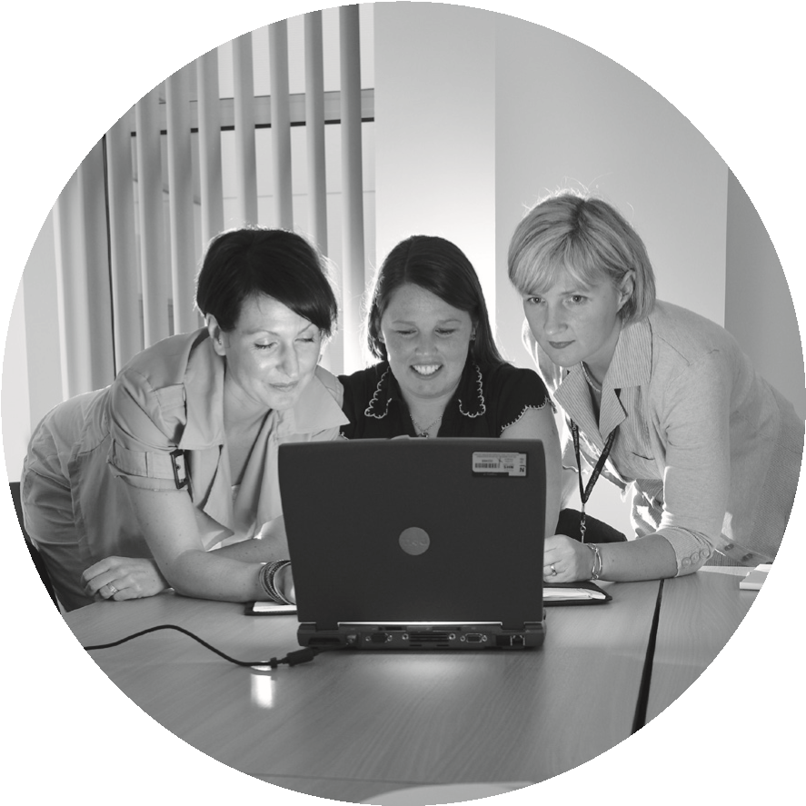

**General Practice**

**Data Collection**

**Data Protection Notice for**

**Who are we?**

We are Practitioner Services Directorate (PSD) which is a Directorate of NHS National Services Scotland (NHS NSS).

NHS NSS is a public organisation created in Scotland under Section 10 of the National Health Service (Scotland) Act 1978.

NHS Education for Scotland (NES) is an education and training body and a national health board within NHS Scotland.

**What is this notice about?**

This is a Data Protection Notice about the General Practice Data Collection. It tells you about the way we collect, store and use personal information. It also tells you what your rights are under data protection law, how you can request to see your information and what to do if you have any concerns about our management of personal information.

**the General Practice Data Collection App**

**About the GP Data Collection**

PSD and NES have been commissioned by the Primary Care Division of Scottish Government to collect data to support the General Medical Services (GMS) Contract negotiations and

Primary Care Workforce Planning. The General Practice Data Collection collects information on general practitioners and practice employees on their working patterns, absences etc.

GP practices are required to provide the following data to cover a 12-month period: Individual staff data - job roles, contract type, hours/sessions worked, date of birth and sex.

Workforce data – aggregate information on absence (sick leave, maternity leave and paternal leave) and vacancy information for staff employed by the practice.

**Why do we need to collect and hold personal information?**

Personal information is information that identifies you. It includes things like your name and age. The information collected in General Practice Data Collection includes some personal information about staff working in GP practices:

* Date of birth and sex.
* Hours/sessions worked.
* Reason for leaving a job.

This information is being collected to understand the demographics of the GP practice workforce population. This will provide data to support both the Scottish Government and Health Boards in continues workforce planning.

**What is our legal basis for using personal information?**

PSD & NES must comply with the law to hold and use personal information, and that requires us to demonstrate we have a clear need to do so. To meet the obligations under The National Health Service (General Medical Services Contracts) (Scotland) Regulations 2018 [www.legislation.gov. uk/ssi/2018/66/contents/made](http://www.legislation.gov.uk/ssi/2018/66/contents/made) and the 2018 Scottish General Medical Services Contract [www.gov.scot/binaries/content/ documents/govscot/publications/ advice-and-guidance/2017/11/2018gms-contract-scotland/ documents/00527530-pdf/00527530-pdf/ govscot%3Adocument/00527530.pdf](http://www.gov.scot/binaries/content/documents/govscot/publications/advice-and-guidance/2017/11/2018-gms-contract-scotland/documents/00527530-pdf/00527530-pdf/govscot%3Adocument/00527530.pdf)

GPs must provide robust and reliable data about their Practices to inform the phased approach of the contract and workforce planning. Therefore, processing of personal information is necessary for compliance with the legal gateway provided through the general medical services contract and as part of our tasks that we carry out in the public interest; for example, providing data for planning of GP Practice services.

A small amount of personal information we collect relates to health, and so it is considered to be ‘special category’. This information comprises ‘reasons for leaving the post for ill-health’ which are necessary for workforce planning. Therefore, this information is considered to be ‘special category’ information under the law. Our legal basis for using this special category information is usually that it is necessary for statistical and historical research purposes to understand trends and patterns.

**How long can we keep your personal information for?**

The NHS Code of Practice sets out minimum retention periods for information, including personal information, held in different types of records including personal health records and administrative records. As directed by the Scottish Government in the Records Management Code of Practice, we maintain a retention schedule detailing the minimum retention period for the information and procedures for the safe disposal of personal information [www.nhsnss.org/how-nss-works/ document-storage-and-retention](http://www.nhsnss.org/how-nss-works/document-storage-and-retention).

In accordance with our retention policy, we hold aggregate information about GP Practices indefinitely as they can be used in investigations such as discrepancies, and support our statistical purposes. Aggregate data may continue to exist in official documents (for example, the annual publications).

**How do we keep your personal information secure?**

We take care to ensure your personal information is stored securely and is only accessible to authorised people. Our staff have a legal and contractual duty to keep personal health information secure, and confidential. The following security measures are in place to protect personal information:

* All staff undertake compulsory training in information governance which comprises data protection and IT security.

• NSS and NES have to comply with the NHS Scotland Information Security Policy set out by Scottish Government.

* We have senior staff who have the role of ‘Caldicott Guardian’ for our organisation. The job of a Caldicott Guardian is to ensure that we take all appropriate steps to protect the confidentiality of personal information.
* Access to personal information can only be given with special authorisation, and use of that information is monitored closely.
* We have policy and procedures on the safe handling of personal information, from when we receive it to when it is securely removed or destroyed when no longer needed.
* There are strict rules that govern how information should be managed eg to make sure names, addresses and any other information that might identify an individual are removed wherever possible before analysis.
* When we publish reports from the information we hold, we ensure no individual can be identified from the information we publish.
* When we work with personal information, we make sure we only use the minimum information required for us to undertake our role.

**What are your Rights**

This section contains a description of your data protection rights.

# i. The right to be informed

As an organisation, we must explain how we use your personal information. We use a number of ways to communicate how personal information is used, including:

* this Data Protection Notice
* information leaflet
* discussions with your GP Practice Manager.

# ii. The right of access

You have the right to access your own personal information. This right includes making you aware of what information we hold along with the opportunity to satisfy you that we’re using your information fairly and legally. If you’d like to access your personal information, get in touch with us with the details of your request using the following contact details:

NSS Data Protection Officer

Gyle Square

1 South Gyle Crescent Edinburgh EH12 9EB

Tel: 0131 275 6000

Email: nss.dataprotection@nhs.net

Once we’ve received your request and you’ve provided enough information for us to locate your personal information, we’ll respond to your request within one month (30 days). However we may take longer to respond – by up to two months – if your request is complex. If this is the case we’ll tell you and explain the reason for the delay.

# iii. The right to rectify personal information

If the personal information we hold about you is inaccurate or incomplete, you have the right to have this corrected – this is called the right to rectification. You can notify us by contacting our Data Protection Officer at the address above. If it’s agreed that your personal information is inaccurate or incomplete, we’ll aim to amend your records within one month or within two months where the request is complex. If more time is needed to fulfil your request, we’ll contact you as quickly as possible to let you know. We will have to refer to the GP Practice that supplied us with the data to enable them to make an assessment of the request and resubmit if necessary. Where erroneous data are identified, they can easily be replaced.

**iv. The right to object**

You have the right to object to your personal health information being included in the GP data collection tool. You can notify us by contacting our Data protection Officer at the address above.

However, where contractual and legal obligations require GP Practices to submit the data, we may have compelling reasons to continue our processing and it is unlikely that your request will be upheld.

**v. The right to complain**

We employ a Data Protection Officer to check that we handle personal information in a way that meets data protection law. If you’re unhappy with the way we use your personal information, please contact our Data Protection Officer at the address given above.

You also have the right to complain about how we use your personal information to the Information Commissioner’s Office (ICO). You can find details on how to complain on the ICO website ([https://ico.org.uk/)](https://ico.org.uk/).

# vi. Other rights

There are other rights under current data protection law. These rights only apply in certain circumstances. Download information on your other data protection rights (PDF, 47KB) ([https://nhsnss.org/media/2859/ nss_ data_protection_notice__other_rightsaccessible.pdf](https://nhsnss.org/media/2859/nss_%20data_protection_notice__other_rights-accessible.pdf))

**Accessibility and translations**

If you need this information in another format or a community language, please contact:

Email: NSS.EqualityDiversity@nhs.net

Tel: 0131 275 7457

Text relay: 01800 275 7457

Website: <http://contactscotland-bsl.org/reg/>

**For more information**

You can contact the GP Practice Data Collection team at:

NHS NSS Practitioner Services Division

Gyle Square

1 South Gyle Crescent

Edinburgh EH12 9EB

Email: [nss.gpdatacollection@nhs.scot](mailto:nss.gpdatacollection@nhs.scot)